Notes application Project pictures

Total images: 16

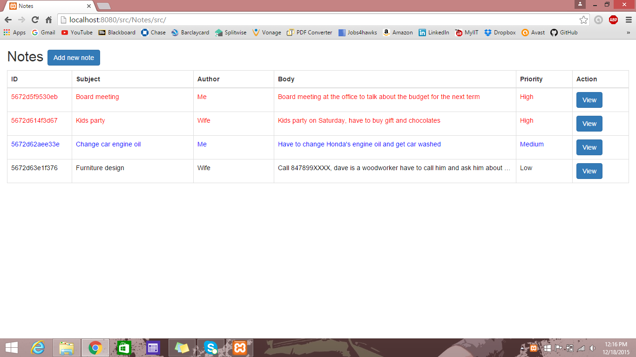

Fig 1: Home page

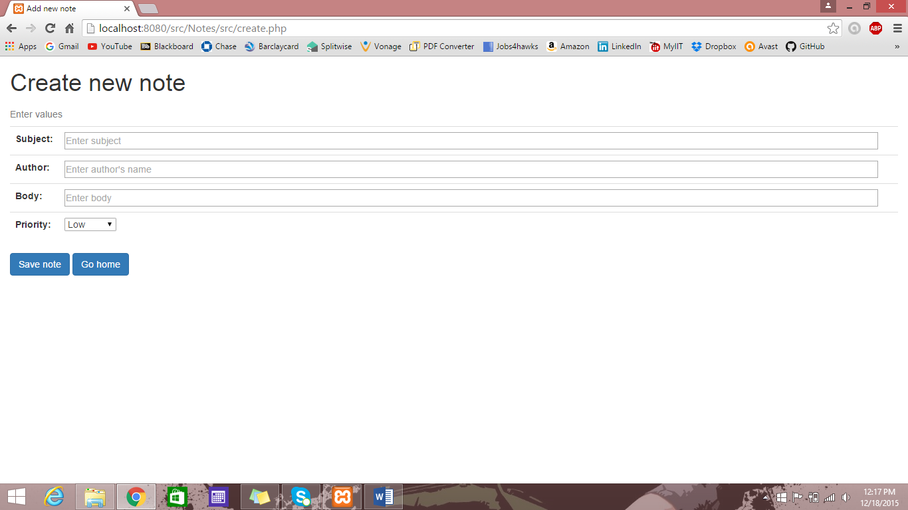

Fig 2: Create new note page

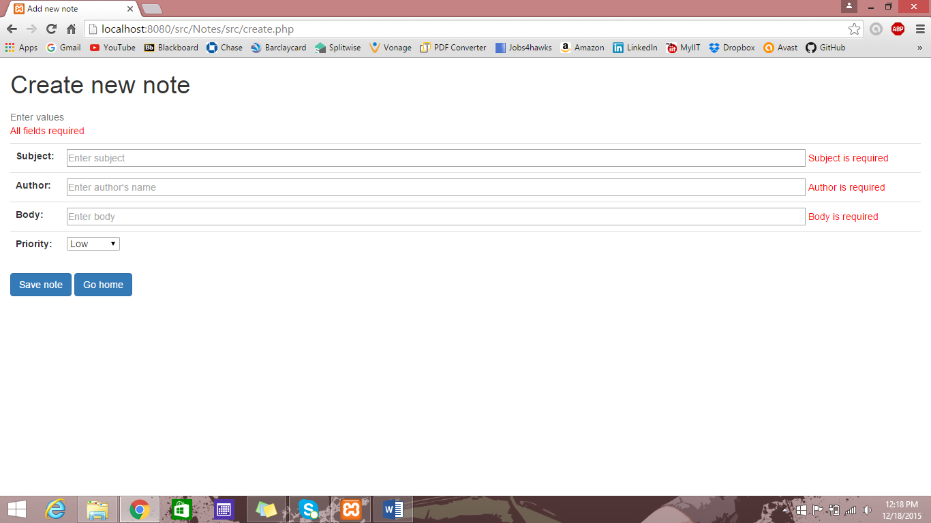

Fig 3: If the fields in the create new page are left empty then the page will again come up with error message

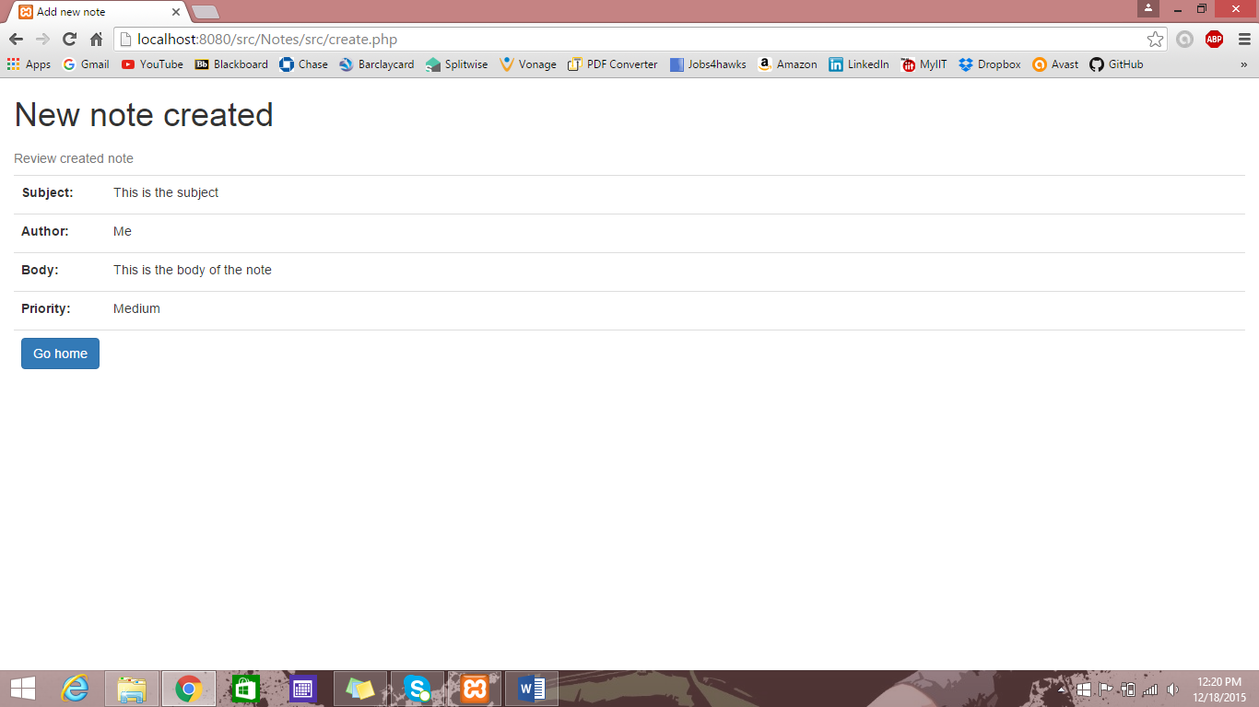

Fig 4: Ones the note is created the application will ask the user to review the new note

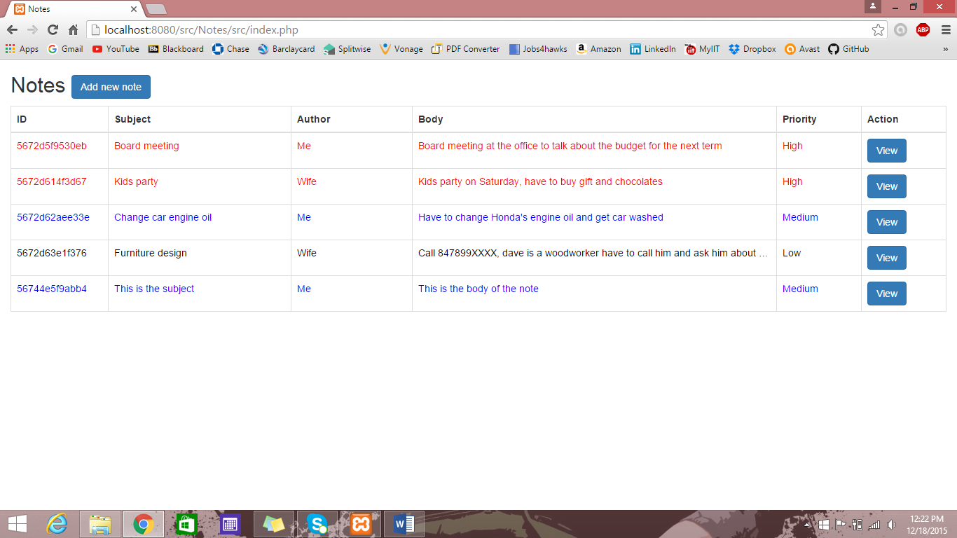

Fig 5: The new note will be added to the application, as the **“priority”** is **“Medium”** the row text will be **“blue”** in color

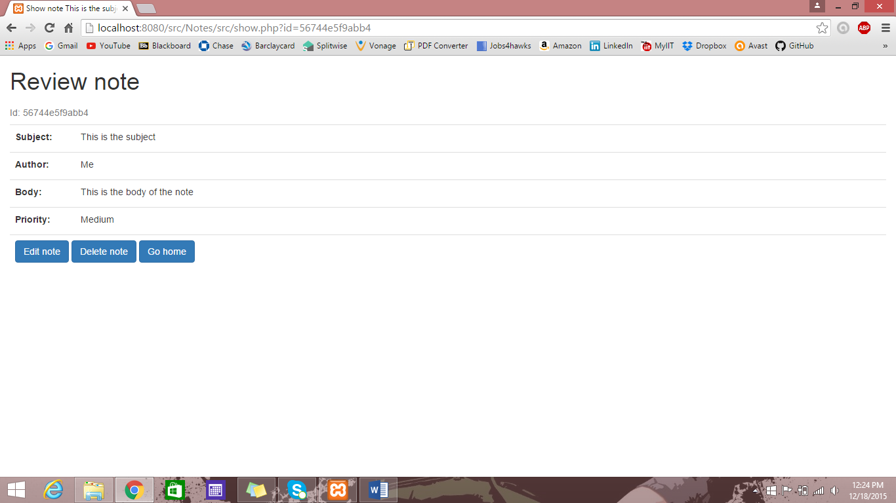

Fig 6: The view button in the action column will take us to show page, where detailed representation of each columns can be seen. Along with this there options to **“edit”** the note and **“delete”** the note.

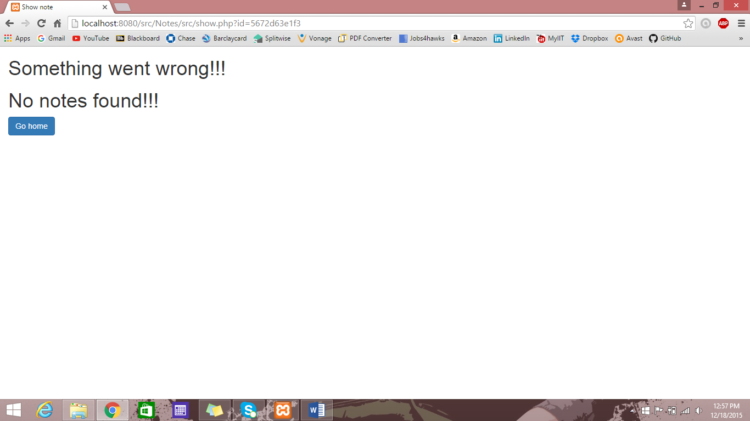

Fig 7: The user can get the detailed information of the note through url in the address bar where the parameter used is ID, but if the user enters wrong ID parameter then there will be an error page

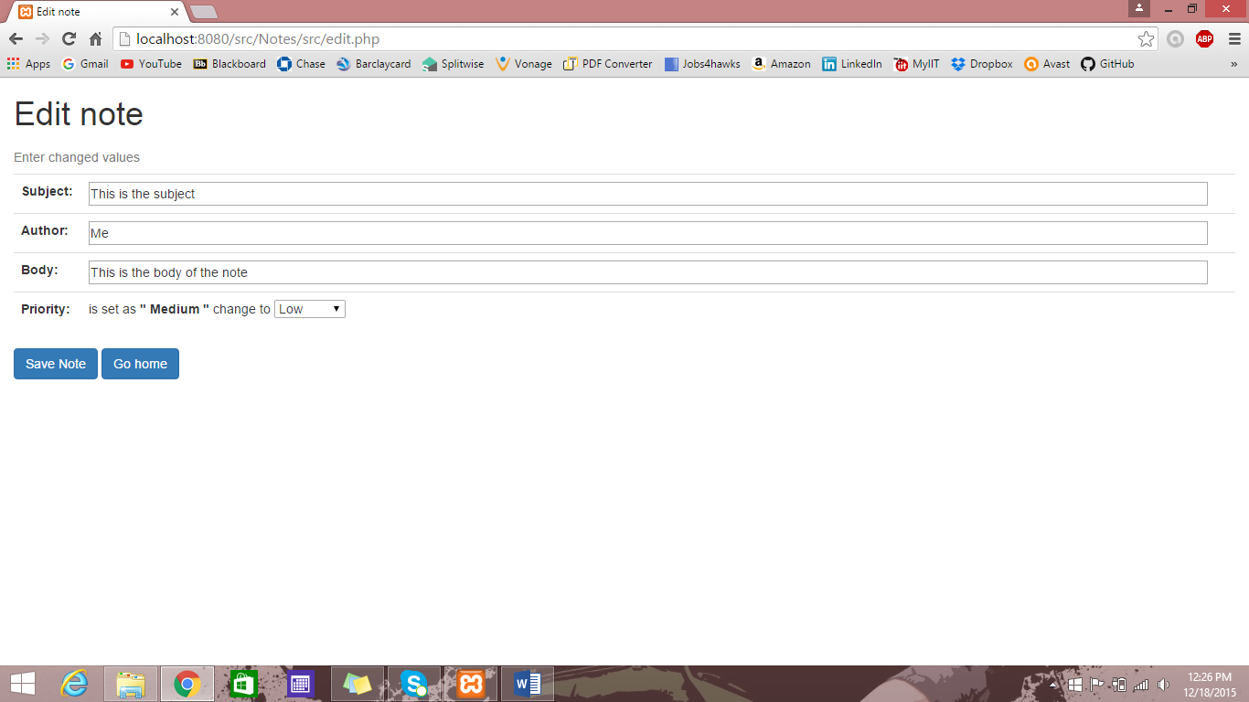

Fig 8: The edit button on view page will take us to edit page where that notes fields will be prefilled in all the fields, we can save the previous or change it to new

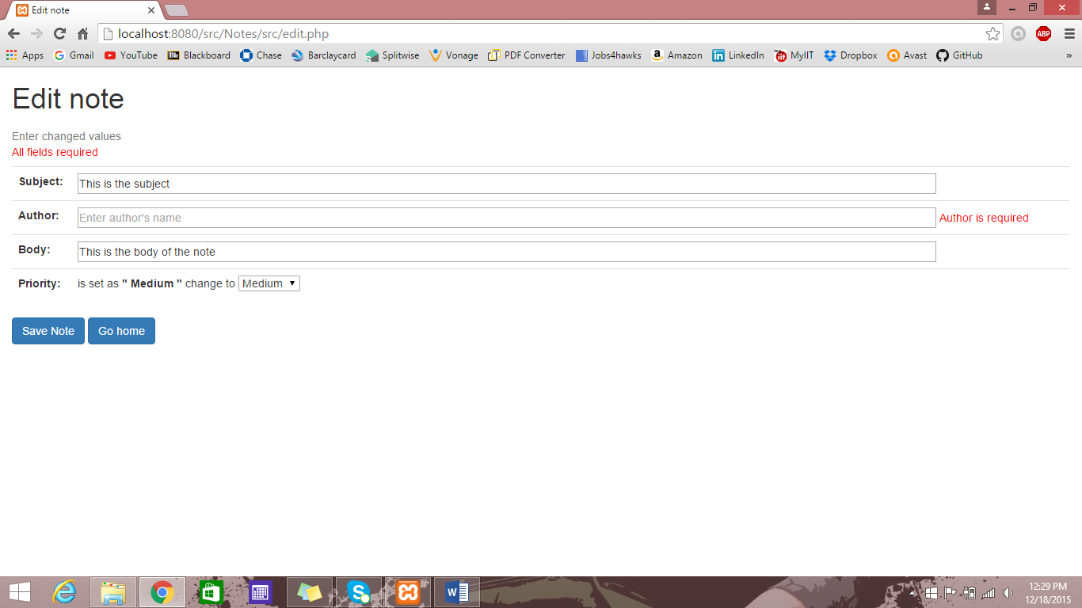

Fig 9: If the fields in the edit page are left empty then the edit page will again come up with error message

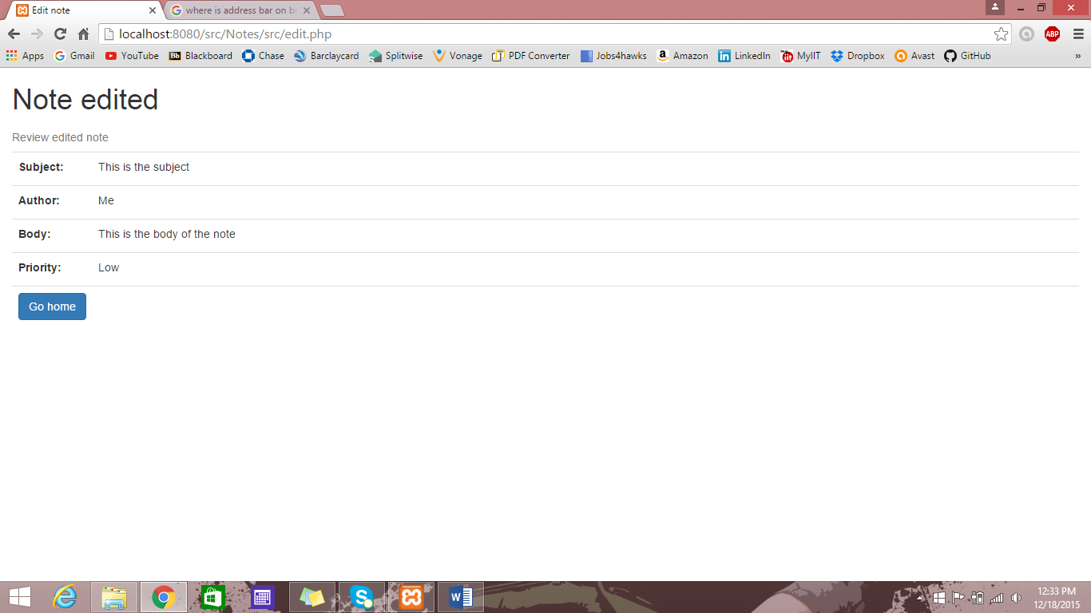

Fig 10: Ones the note is edited the application will ask the user to review the edited note

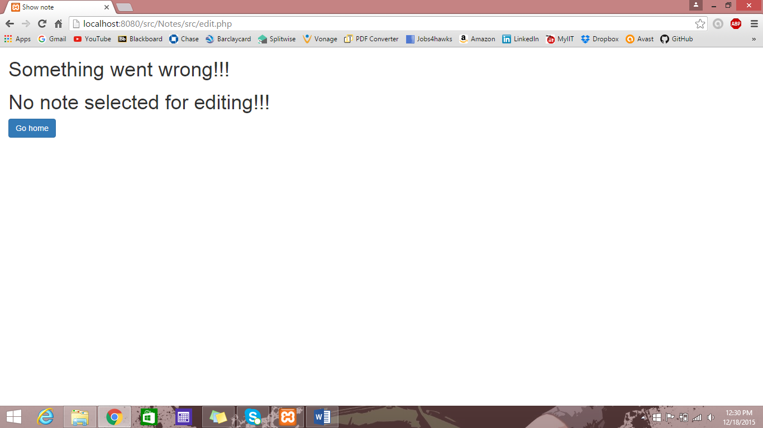

Fig 11: If the user tries to access the edit page through the url in the address bar then there will be an error page as we need to have a note selected to edit it which will be through the application and not with the url

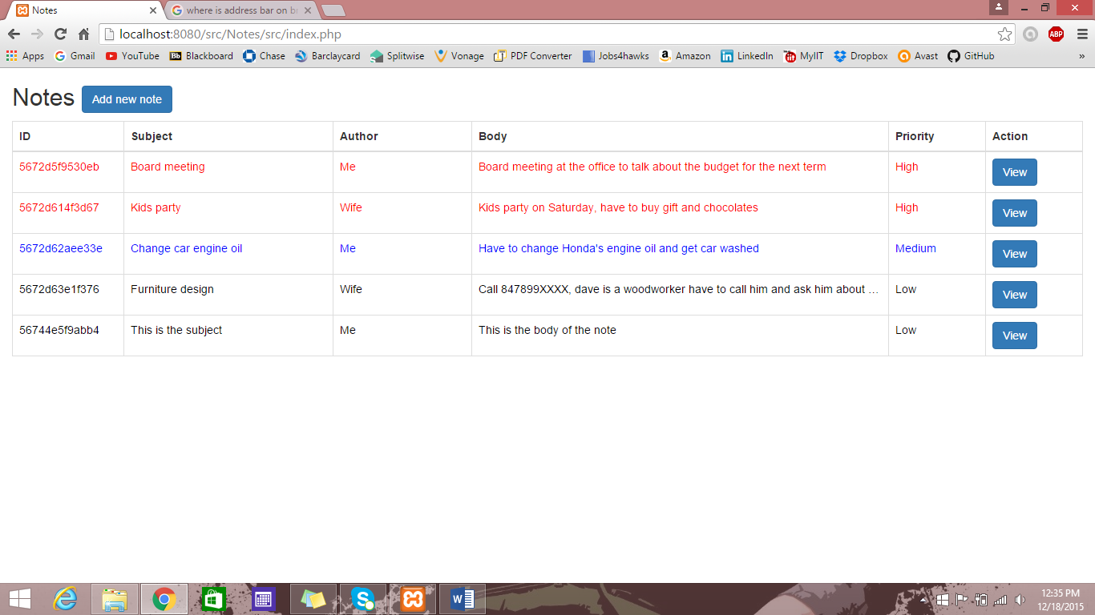

Fig 12: We can see here the note with **“Id - 56744e5f9abb4”** was **“blue”** I color but with change in **“priority”** from **“medium to low”** it became **“black”** in color this is how we can differentiate between two notes based on their priority

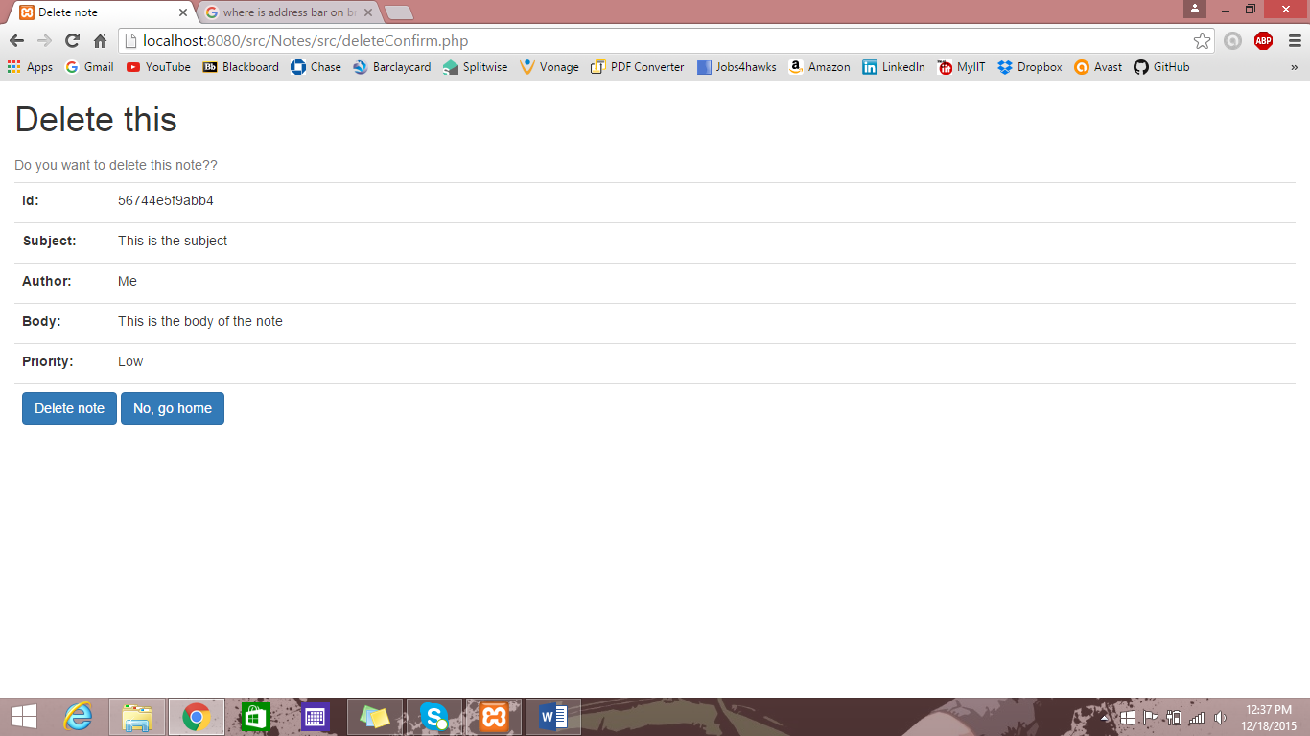

Fig 13: The delete button on view page takes us to delete page where the user is asked for confirmation as this note will be lost for ever

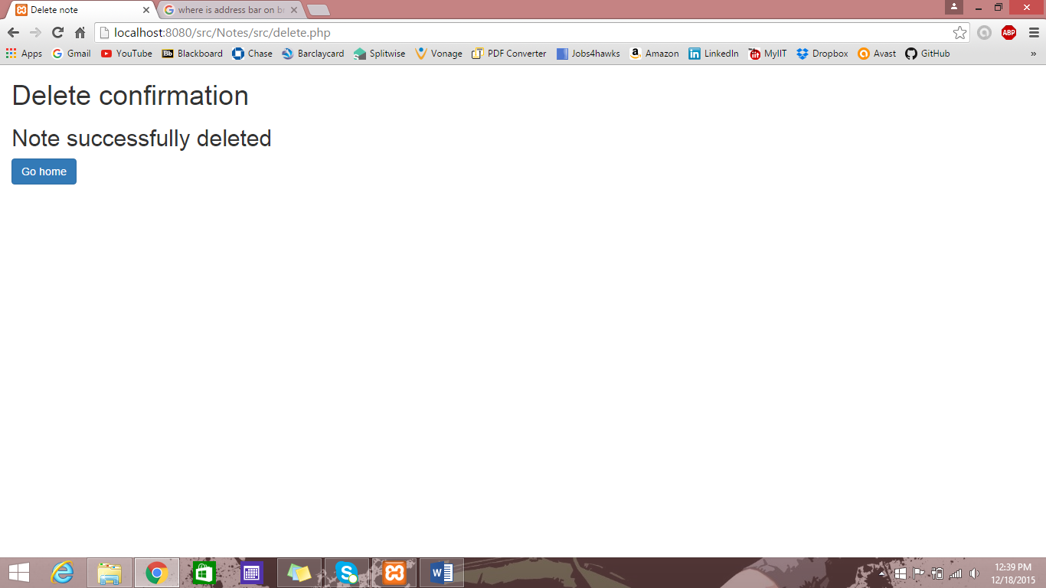

Fig 14: If delete option is selected the note will be deleted forever and there will be a message that the note was successfully deleted from the application

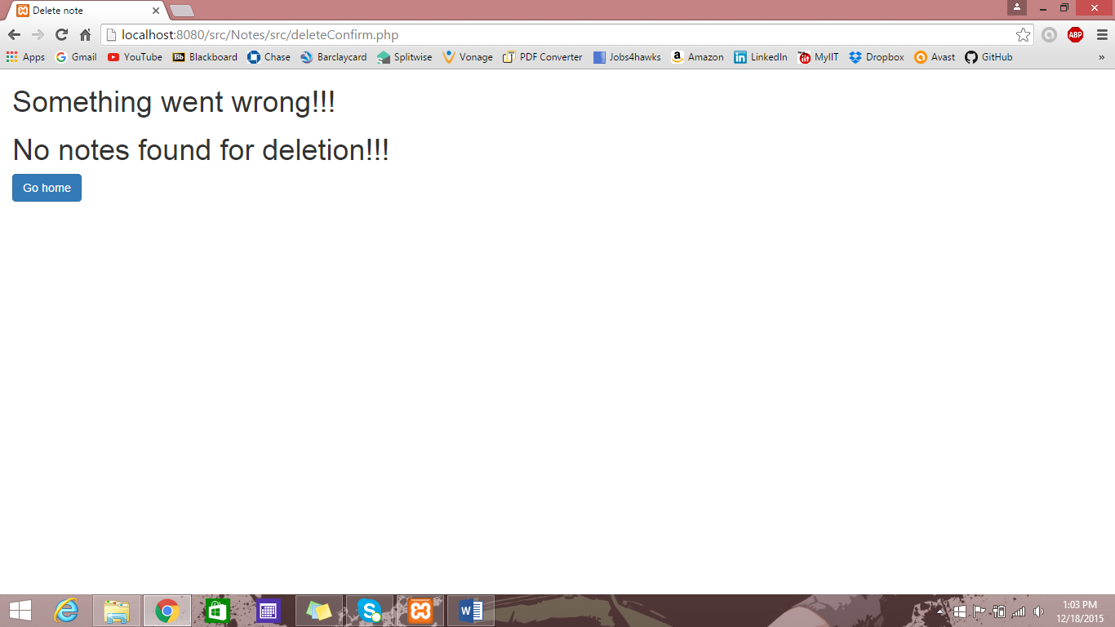

Fig 15: If the user tries to access the delete page through the url in the address bar then there will be an error page as we need to have a note selected to delete it which will be through the application and not with the url

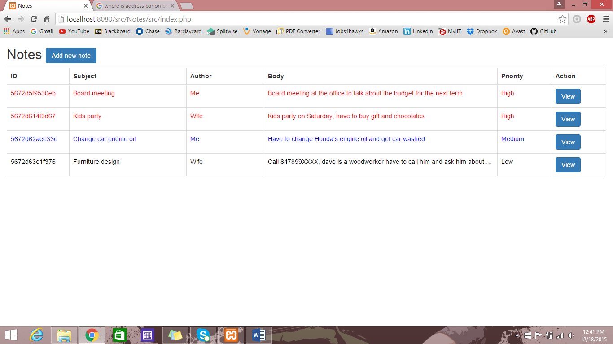

Fig 16: Note with Id - 56744e5f9abb4 is deleted from the application